Memory Hierarchy & cache

Memory addresses
A word is the smallest addressable unit in memory.
- Words can be different sizes depending on the system (e.g. 32-bit or 64-bit).
Words in memory are arranged in groups known as blocks.
- Blocks can be different sizes depending on the system.
A memory address uniquely identifies a word. It is composed of two fields:
- The block field tells us which block the word is in.
- The offset field tells us where the word is within the block (also referred to as the word field).
  - e.g.: 01010 011₂ is word 3₁₀ in block 10₁₀
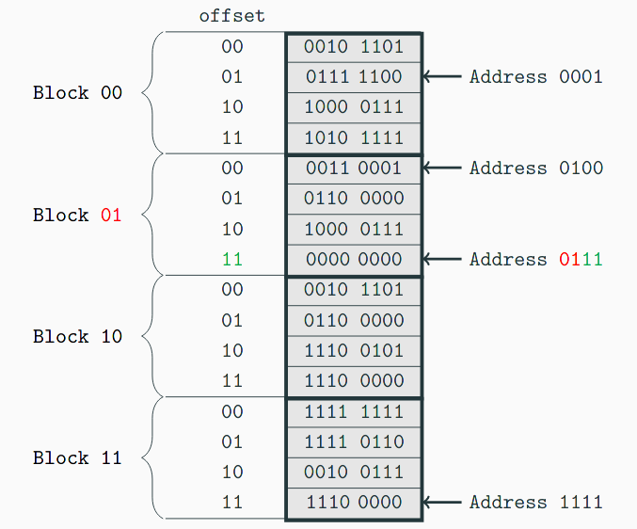
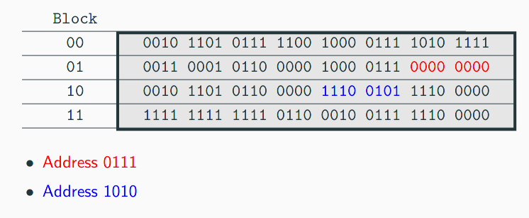

Assume a memory consists of 2¹⁴ words, and each block has 8 words.
- How many blocks does main memory have?
  - Number of words / block size = number of blocks
  - 2¹⁴ / 8 = 2¹⁴ / 2³ = 2¹¹ blocks.
  - There are 2¹⁴ addresses, so we need to represent this many values. We can represent 2¹⁴ values in 14 bits.
What are the field sizes of the address?
- 11 bits to identify the block.
- 3 bits for the offset.

Memory hierarchy
Financial cost can certainly be a limitation to creating the most efficient computing system.
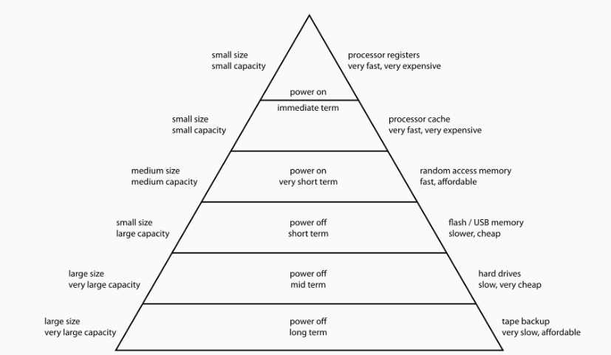
Memory can have:
- Small size and low latency
- Large size and high-latency
Computer systems typically have multiple types of memory. By using memory types in a smart way, we can get the best of all words.

Exposed Hierarchy
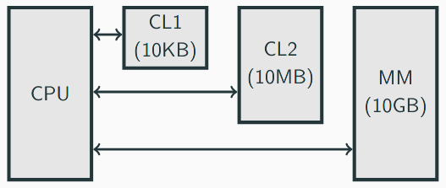

The processor has direct access to each storage form.
- It is the programmer’s responsibility to decide where they want to store their data.
This is rarely used because it requires complex load and store instructions in instruction set, and programs will compete for memory.

Implicit memory hierarchy
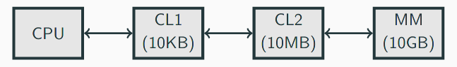

The complexities of the memory are hidden from the processor.
- The hardware handles whether data is stored in fast or slow memory depending on usage patterns.
The processor will “see” fast memory as long as hardware keeps the required data within the cache, however the processor needs to handle different latencies on the fly. This is the most commonly used hierarchy.

Effective access time
Processor sends access request for a particular address to the cache.
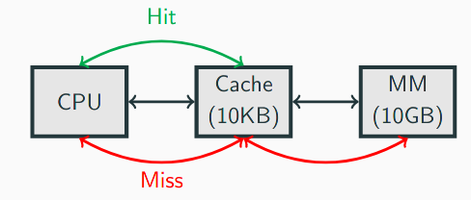
- Cache hit: The data for the address is in the cache.
  - The data can be returned immediately.
- Cache miss: The data for the address is not in cache.
  - The request is passed to main memory (high latency)
  - Memory returns data to the processor (via cache).
  - Temporal locality: retain this data in the cache
  - Spatial/sequential locality: also request additional “close” addresses from memory
Hit ratio: HR = hits / (hits + misses)
Miss ratio: MR = misses / (hits + misses)
Therefore, the Effective Access Time:
EAT = HR * cache access + MR * (cache access + main memory access)
EAT = cache access + MR * (main memory access)
- We aim to get the EAT as low as possible.
Improving the cache isn’t always the be-all-end-all solution. If the miss ratio is too high, it’s not always going to be faster.
Consider a single cache system with the following properties:
- Cache access speed (hit time): 4 cycles
- Main memory access time (miss penalty): 100 cycles.
What is the EAT if we do not use the cache at all?
- Every request goes straight to main memory – 100 cycles.
What hit ratio do we need to ‘break even’?
- 100 = 4 + (1 – HR) * 100 –> H4 = 0.04 = 4%
What is the EAT for a hit ratio of 50%?
- EAT = 4 + (1 – 0.5) * 100 = 54 cycles
What is the EAT for a hit ratio of 99%?
- EAT = 4 + (1 – 0.99) * 100 = 5 cycles
- Is this HR realistic? Perhaps.

Overlapped access
Access can also be overlapped: the cache is checked in parallel with checking main memory.
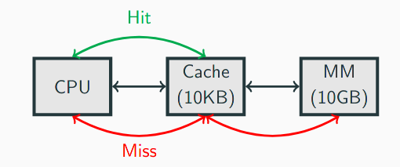
- If overlapped look-up, if the address is not found in the cache, then there is (slightly) less of a penalty.
- However, it requires advanced hardware and more power.
EAT for overlapped access:
EAT = (HR * cache access) + (MR * main memory access)

Cache systems
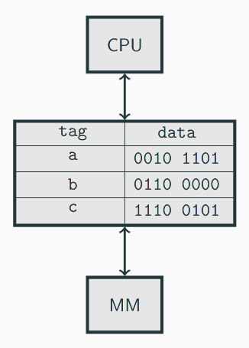
On a request from the processor for the data in memory address m:
- Search tags in cache:
  - Hit: m is a tag
    - Return data
  - Miss: m is not a tag.
    - Read data at address m from memory.
    - Return data
    - Select an address in the cache to hold m and its data (according to replacement policy).
    - Store m in tag with data
But how do we oragnise this? There are different approaches.

Direct-mapped cache
Each block in memory maps into a single, specific cache block.
A direct mapped cache consisting of N blocks, block X of main memory maps to cache block Y:
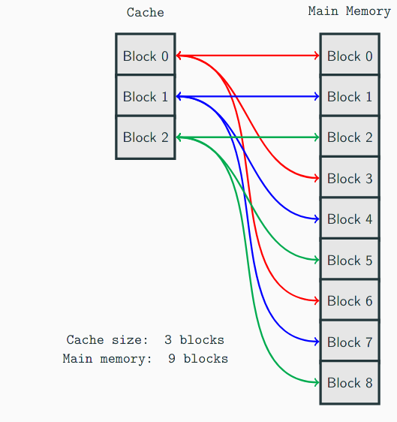
- Y = X mod N
Example: in a system with an 8 block cache and a 32 block main memory:
- Block 5 of main memory will be stored in block 5 of the cache.
- Block 25 of main memory will be stored in block 1 of the cache
- Block 16 of main memory will be stored in block 0 of the cache.
A tag field in the cache block distinguishes one memory block from another. An address is composed of the following:
- The block field: the number of bits required to address all cache bloks.
- The offset field: the number of bits reuired to address all words within a block.
- The tag field: the number of bits left over after the block and offset.
  - e.g.: 001101110
Assume a cache of 8 blocks and a main memory of 32 blocks, where each block is a single byte, and the system is nybble-addressable.
- There are two words per block (two nybbles in a byte).
- There are 64 words (32 blocks * 2 nybbles). Addresses for a 64-word memory will need 6 bits (64 = 2⁶)
  - The offset field will be 1 bit (2 = 2¹, only 2 words in a block).
  - The block field will be 3 bits (8 = 2³, 8 blocks in the cache).
  - The tag field is 2 bits (2 = 6 – 1 – 3, whatever is left over).
- Addresses for an 8 block cache will be 3 bits (2³ = 8)
Example address (51₁₀):
- 51₁₀ = 110011₂ –> cache block 1₁₀, offset 1₁₀, tag 3₁₀.
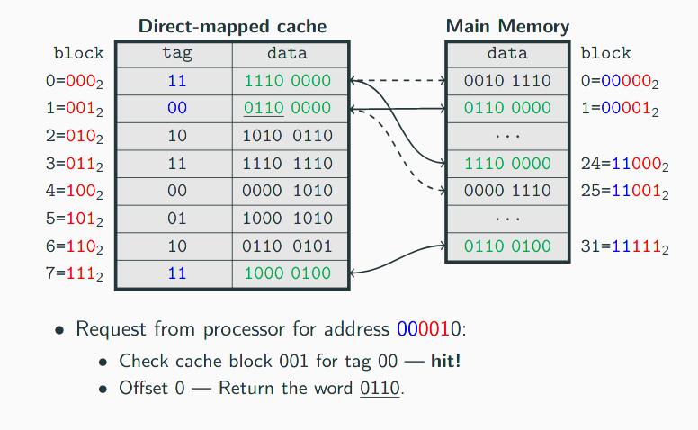
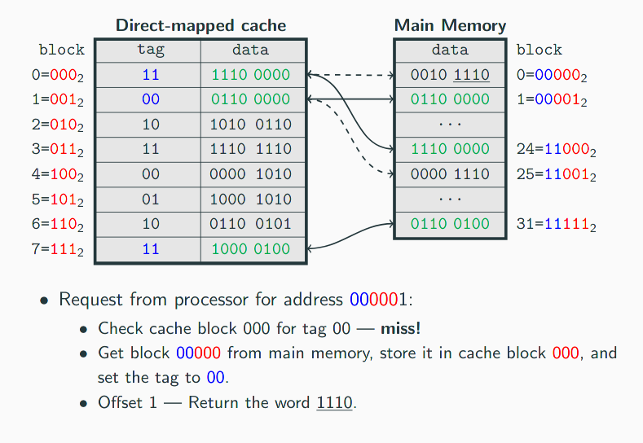

Fully associative cache
Suppose, instead of placing memory blocks in specific cache locations based on memory address, we could allow a block to go anywhere in the cache.
An address is composed of only two fields:
- Tag field: this is the block of main memory
- Offset field: the position of the word within the block.
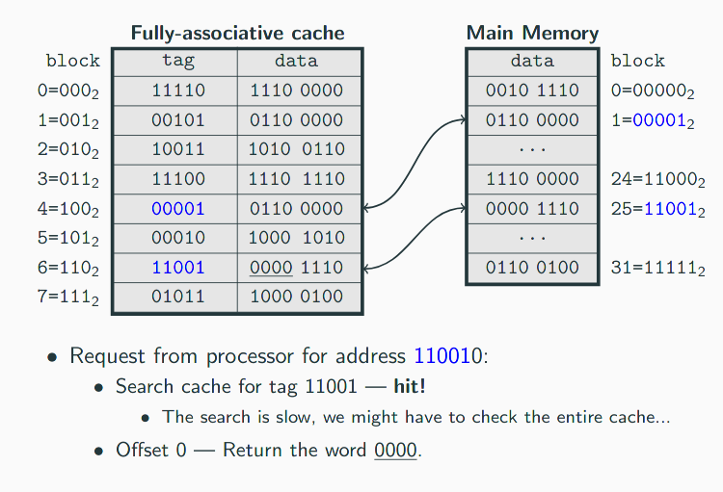

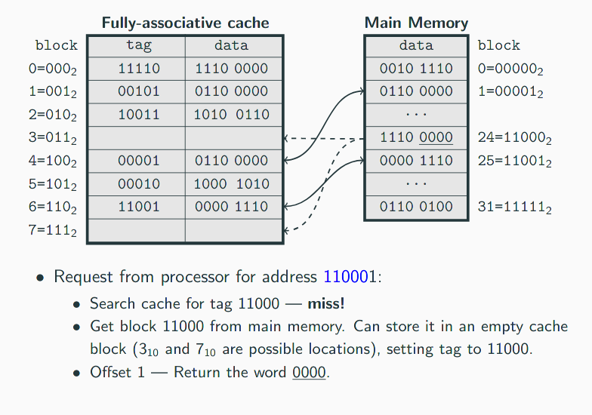

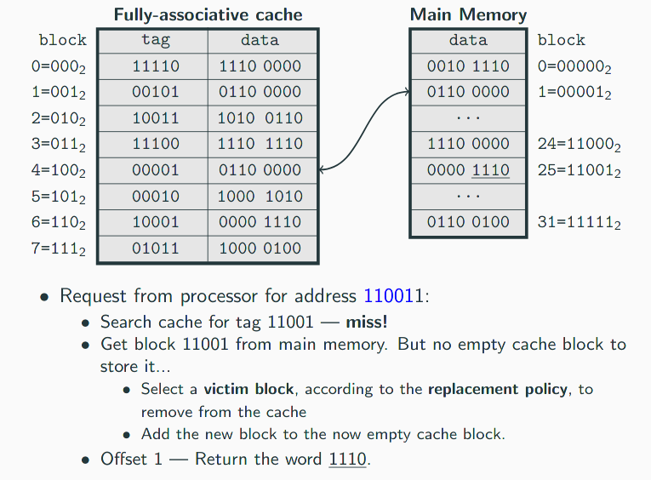

In fully associative caches we may have to search the entire cache to try to find a particular tag – This is an expensive process.
In direct-mapped cache the search is fast (there is only one location in the cache where a particular address can be stored, so there is no search needed). However, direct-mapped is overly rigid.
- In our direct-mapped cache example, imagine if address 000000 was requested, then 110000, then 000000, then 110000, …
- Both addresses map to different memory blocks but the same cache block.
- So we would have to constantly be removing and adding the same blocks to the cache (thrashing) even though we areo nly accessing two blocks, which is also an expensive process.
We need to balance these two concerns – set-associative cache.

Set associative cache
These combine the ideas of direct-mapped and fully-associative cache.
- The cache is divided into contiguous equal-sized sets.
- An n-way set-associative cache has multiple sets of n blocks.
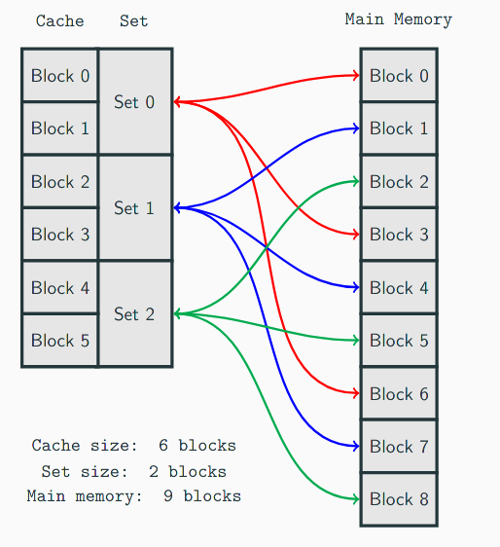
- Each address maps to only one set (MM block number mod number of sets), but can be stored anywhere within that set.
- An address is composed of the following:
  - Tag: uniquely identifies which main memory block is in the cache (in combination with the set).
  - Set: uniquely identifies which set in the cache.
  - Offset: uniquely identifies which word in the block.
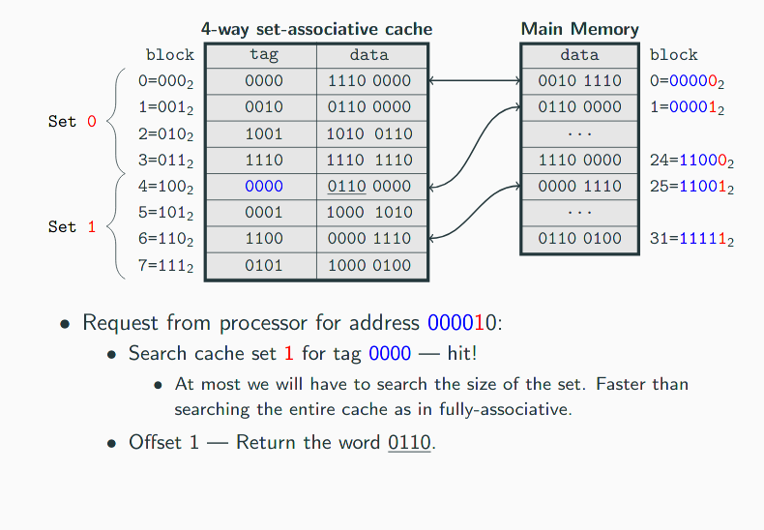
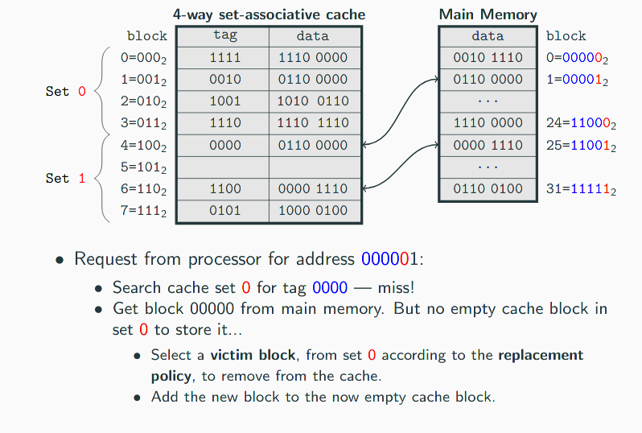

Replacement policies
Wit hassociative caches a replacement policy is required when deciding which block to remove from a full cache.
- The block to be removed is called the victim block.
In most domains, the optimal replacement policy is not possible – we would need an oracle machine to look into the future of the computer system to tell us which block currently in the cache is not needed for the longest period of time.

LRU
If we want to optimise for temporal locality we will want to keep recently used blocks in the cache and remove blocks that haven ot been used for a long time.
- We can emply a least-recently used (LRU) algorithm to keep track of the last time each cache block was accessed.
- The victim block is then the block which has been unused for the longest period of time.
- However, the LRU algorithm is complex: we have to maintain an access history for each block – this takes up memory and time, and slows down the cache

FIFO
A first-in first-out policy is a popular and simple cache replacement policy.
- In FIFO, the block that has been in the cache the longest is the victim block.
- A slight disadvantage is that we still have a (small) overhead for keeping track of which block has been in the cache for the longest.

Random
A random policy just selects a block at random and replaces it with a new block.
- No overhead.
- Equyally likely to remove best blocks and worst blocks.

